Challenge:
Create a simulation with a square containing a inscribed circle. If points are randomly chosen throughout the square, some will fall inside the circle. It turns out that the ratio of the number of points inside the circle to the total number of points generated is 1/4th of a very interesting number. Can you find the interesting number? And can you determine why that number is appearing in the simulation?

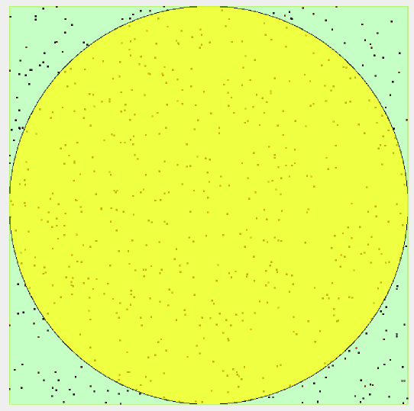

Things you’ll need to know:
- How to use playfields and stamping objects
- How to use variables

Things to think about:
- How can you randomize the location of points and leave a marker behind?
- How can you tell if the point is inside the circle versus just the square?

How to do it:
- See below!

Extensions:
- What would happen if you used a rectangle with an inscribed ellipse?

Geometric Probability Lesson

- In the world, create three number variables: inCircle, total, and fourTimesQuotient. The first two can be integers, but the last variable should have as many decimal places as possible.
- Drag a playfield to the world and name it square. Drag an ellipse to the playfield and name it circle. Drag another ellipse to the playfield and name it point.
- For the square set the width and length to be some large number (say 400). For the point, set the width and length to be a very small number (say 3). You don’t need to change the circle’s width and length (yet). Make sure all three have different colors.
- Create a World script named randomPoint. It should first randomize the position of the point to be somewhere in the playfield. The formula I used for the x-coordinate was: random(square width + 1) - 1. Do something analogous for the y-coordinate. Next, tell the point to show. Now, test if the point is overlapping with the circle - if so, the World’s inCircle variable should increment by 1. After the test, increase the World’s total variable by 1. Assign the World’s fourTimesQuotient variable to be 4 * inCircle / total. Finally, have the point stamp and then hide itself.
- Create a World script named startSim. It should tell the randomPoint script to start.
- Create a World script named stopSim. It should tell the randomPoint script to stop.
- Create a World script named resetSim. Set the circle’s width to be the same as the square’s width. Also set the circle’s length to be the same as the square’s length. Next, set the circle’s x to be the same as half the square’s width. Also set the circle’s y to be the same as half the square’s length. Set the World’s inCircle, total, and fourTimesQuotient variables to 0. Finally, tell the square and the circle to erase all pen trails.
- Now, make buttons for the startSim, stopSim, and resetSim button... and you should be done!

