Challenge:
Create a function game of Craps (without betting).
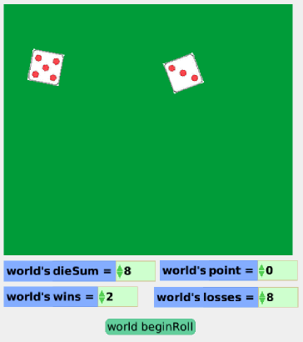

Things you’ll need to know:
- How to animate the image of an object using holders (for the dice)
- The rules of the game of Craps and how to use test statements
- How to use variables
- Starting and stopping scripts

Things to think about:
- How can you tell whether a roll is a first roll (in which case 7 wins) or a subsequent roll (in which case 7 loses)
- How can you make rolling dice that bounce off each other and slow down?

How to to it:
- See below!

Extensions:
- Automate the rolling so we can see what happens after one million rolls. How often do you win? How often do you win on a first roll versus a second roll? Is the game fair?

Craps Lessons

Part A: Random Dice Rolls

Note: there are a LOT of ways to do this, some using several more sub scripts and variables.

- Create a Holder object and add six image objects to the holder that represent the 6 faces of a regular die. Name the Holder dieHolder1.
- Draw a blob object (it doesn’t really matter what it looks like) and name it die1.
- Add a variable to World called rollTimes. It should be a number that is initially 0.
- Create a script for die1 named roll. Have dieHolder1’s cursor be set to a random number between 1 and 6. Set die1’s graphic to be the same as the graphic at the current cursor in dieHolder1.
- Create a script for the World named rollDice. It should tell die1 to roll. It should also increase rollTimes by 1. It should also see test to see if the World’s rollTimes is 50 or greater. If it is, the rollDice script should be stopped.
- Create a script for the World named beginRoll. It should set the rollTimes to be 0. It should also tell the script rollDice to start.
- Make a duplicate of both dieHolder1 and die1. This will give you a second die named die2.
- Now edit the World’s rollDice script so that it starts die2’s roll script.
- Create a button for your beginRoll script. You can hide your three scripts and the two holders.

Bonus #1
- Create a Playfield and put the dice inside. For each roll scripts, have the dice move forward 50 and bounce off the walls.
- In the World’s rollDice, randomize the headings of both of the dice.
- For even more fun, make a variable for the dice speed. Make how far the dice moves be dependent on this variable. As the dice roll, decrement this value.
- CHALLENGE: Can you make it so that the dice can’t stop on top of each other?
- CHALLENGE 2: Can you make it so that you can’t start rolling again until the dice have stopped?

Part B: Die Sum

- Add a number variable to the World called dieSum.
- Drag a monitor for dieSum to the World area so you can see the value change.
- In the World’s rollDice script, set the value of dieSum to be the sum of holder1’s cursor and holder2’s cursor [alternatively, you could have added another variable to each die to keep track of the value]

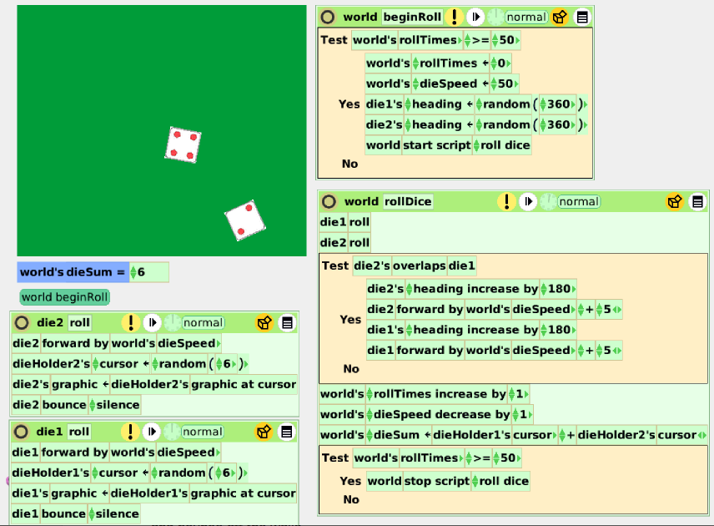

Part C: Implementing Game Logic

- Create a World variable called point. It should initially be 0. Drag a monitor to the World.
- Create two more World variables called wins and losses. They should initially be 0. Drag monitors to the World
- Create two World’s scripts named win and lose.
- In the win script, increase the wins variable by 1 and set the point variable to 0.
- In the lose script, increase the losses variable by 1 and set the point variable to 0.
- Create a World script called processRoll.
- Have processRoll either call the win or lose script under the following conditions. If the point is 0, you lose if you roll a 2, 3, or 12, you win if you roll a 7 or 11, and you set point to match the dieSum. If the point is not 0, you lose if you roll a 7, you win if your roll matches the point, and nothing happens otherwise.
- Edit the World’s rollDice script. Make it call processRoll when the rollDice script is stopped.
