Candle Extinguisher Project for Etoys

Challenge:
Create a car(joystick-controlled) that must navigate a track to a launch area, call(key press) for a randomly placed candle(target), fix(key press) its position, and launch a water balloon(keypress) to snuff it out. Candles can be called and snuffed out until time elapses. How many candles can you snuff out in 60 seconds?
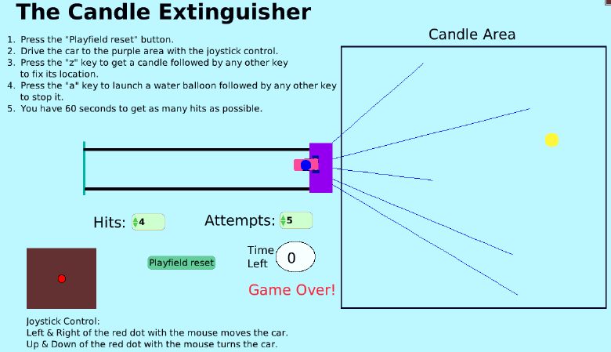

Things you’ll need to know:
- How to use a random number.
- How to show and hide text boxes.
- How to use variables.
- How to use watchers.
- How to connect the car motion to the joystick.
- How to “bounce” off an object.
- How to use nested tests to create an “and” condition.
- How to use pen control.

Things to think about:
- How does the water balloon stay with the car and release with a keystroke?
- How to increment shots when the balloon is released?
- How to increment hits when the balloon is hit?
How to do it:
Candle Extinguisher Lesson

Extensions:
- Make the target a slowly moving candle.
- Make the path to the launch area more difficult to maneuver.
- Make it a 2-player game
Candle Extinguisher Lesson
- Create a car and give it some general movements.
  - Set it to move with the joystick.
  - Set it to bounce off the borders of the track.
  - Check if the car is over the launch area and whether the appropriate keystroke has been pressed to get the candle. If so, make the candle visible and run the script that monitors the balloon launch.
  - Attach the balloon back to the car if a 2nd button is pressed after the “a”.
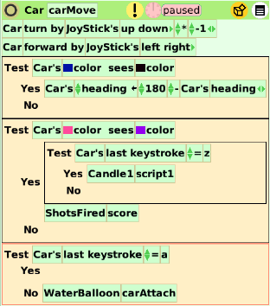
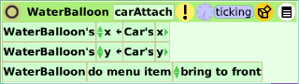

- Locate the candle somewhere in the target area.
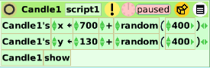

- Monitor the firing action of the water balloon.
  - Keystroke initiates launch and tallies of attempts and hits.
  - Pen is put down, balloon follows car’s heading, and moves forward 20 at a time.
  - Nested Tests check for balloon’s interference with car and candle in order to increase attempts and hits. If hit, the candle is hidden and placed out of the target area so the balloon doesn’t bounce off the wall and pass over its position again.
  - If the balloon is not hit and a keystroke other than “a” is pressed the water balloon is reloaded into the car.

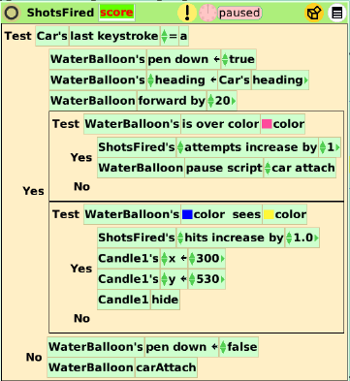

- Monitor the time of the player’s turn.
  - When the timer hits zero pause all ticking scripts.
  - Show Game Over.
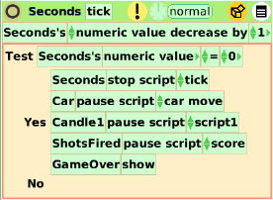

- Have Reset button ready to fire.
  - Put the car at the beginning.
  - Hide candle if not hit and Game Over sign.
  - Lift up pen and erase trails.
  - Put attempts & hits at 0 and clock at 60.
  - Allow car movement and start the clock.
