Geometry Name: ____________________ Date: ________
Hour: ________

Directions: You will be given a figure in Etoys that looks like the following:
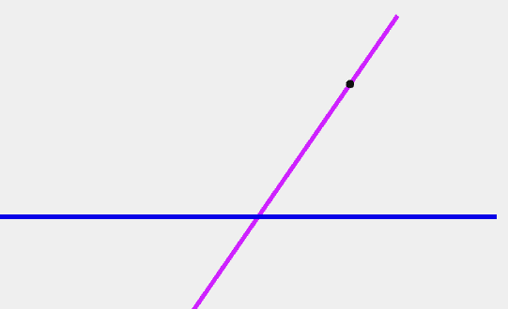
B=B
A

Your goal is to construct a line called “C” that is parallel to line A through the point on line B. The lines should remain parallel even if someone were to rotate line A.

Before you begin, think about the following question: What proves that two lines are parallel? (Don’t simply say that “they don’t intersect.”) Record some of your ideas below.

Begin by constructing a line segment and calling it “C.” What can you do to ensure that line C will go through the point on line B? Write down your ideas and then execute them on the computer.

Now you will need to change the “forward” direction on line C. Follow these instructions. Get a halo on line C. Hold down the “shift” key and click on the green arrow in the middle of the line. Drag the green arrow so that it points in the same direction as line C.
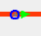
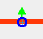

Drag in the direction of the line.
Shift + click on the green arrow.
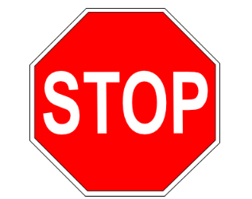
**Check with your teacher to make sure you are on the right track!

Making lines A and C both “horizontal” seems like the correct solution at this point. However, if you were to get the halo on line A and rotate it, does line C remain parallel to it?

Look under the “basic” tab for line C. Get the halo for line C and rotate the line. Observe any changes in the “basic” tab. What do you notice?

Do the same thing for line A that you did for line C in the step above. Does anything change in the “basic” tab? What do you notice?

Rotate lines A and C so that they appear to be parallel. What do you notice between the values listed in the “basic” tabs for both lines? (Are any of the values “close” to each other?)

Your last step is to make a script that ensures lines A and C are parallel, under rotation of line A.

**Check with your teacher to make sure you are on the right track!

Would you have to change your script if you were instructed to make lines A and C parallel under rotation of line C? (Try it on your Etoys app!) Why or why not? Explain using complete sentences.

Explain what “heading” is in your own words. You may use online resources if you cite your sources.

Your final challenge is to construct a parallelogram that maintains its properties under rotation.

